**DSA Inclass 25th April**

**200356A**

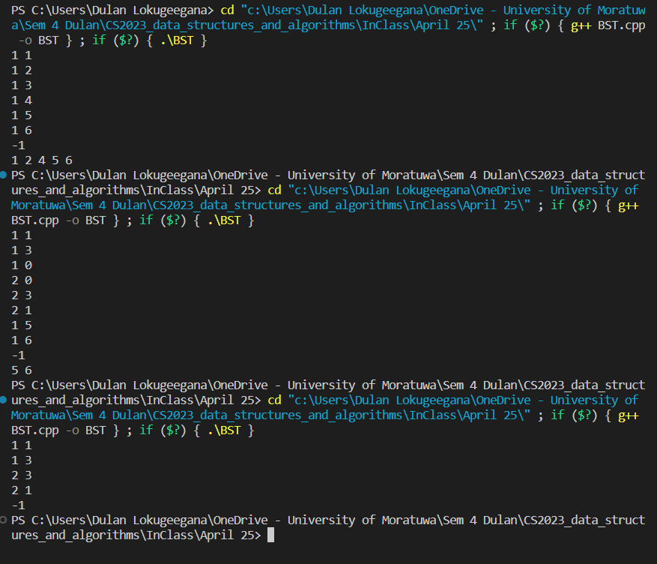

Code link

<https://github.com/Dulan24/S4-CS2023-DSA-labs/blob/master/April%2025/BST.cpp>